**Network and System Administration – Project**

**VirtualBox Installation**

* First, we need to download Virtual Box:

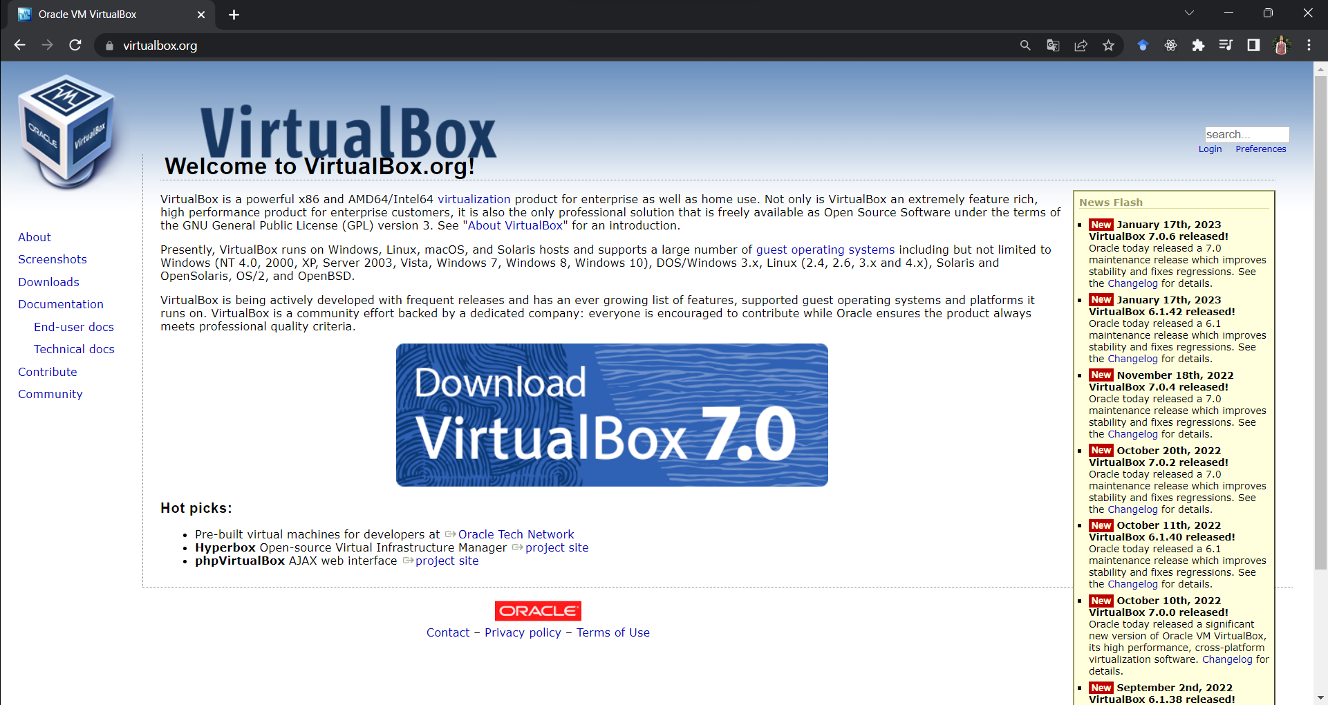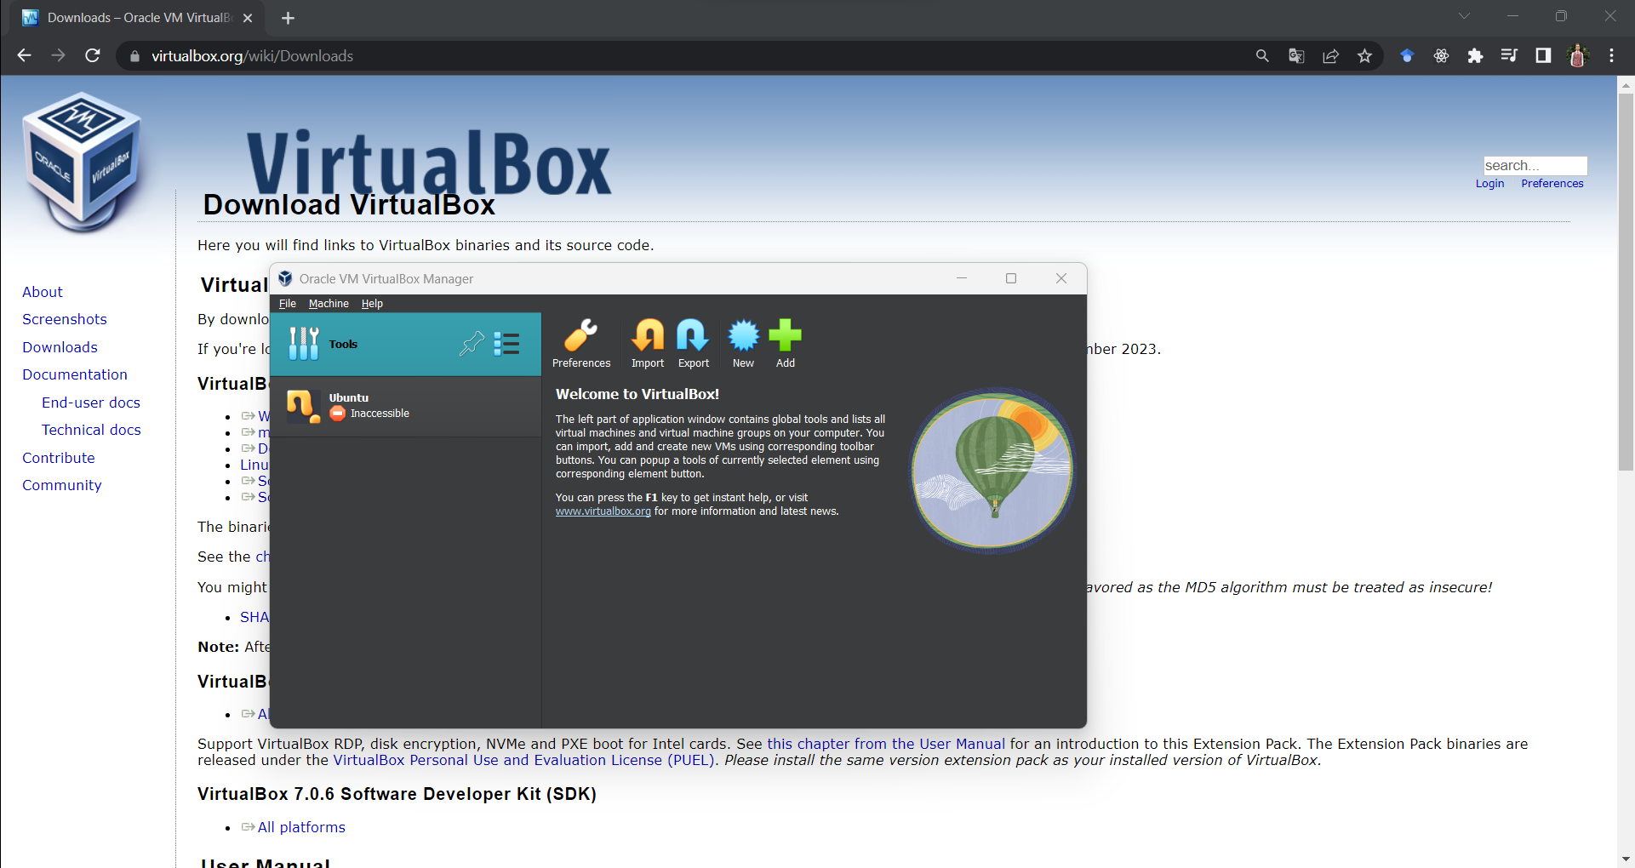

**Ubuntu Server Installation**

* Then, we can install different OSs on it.
* Ubuntu Server Basic Installation:

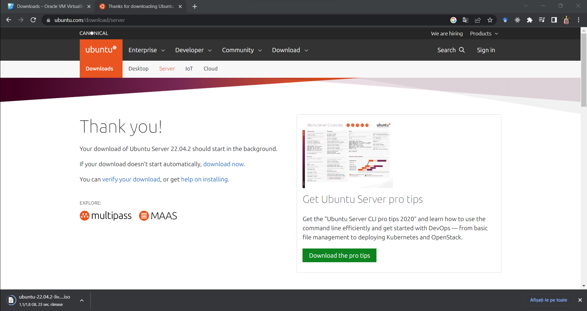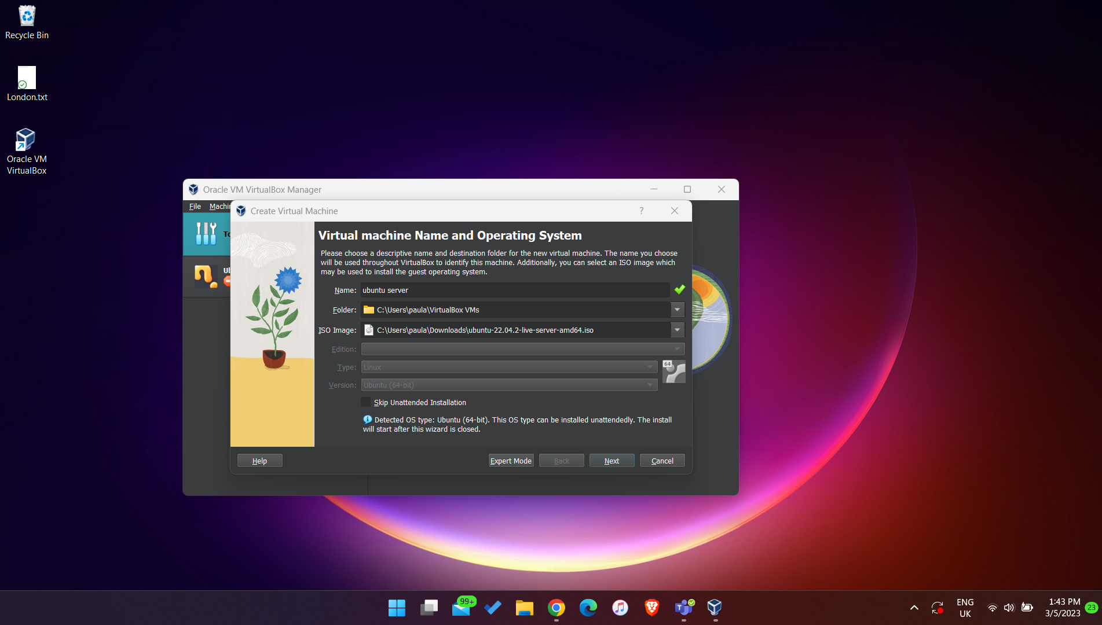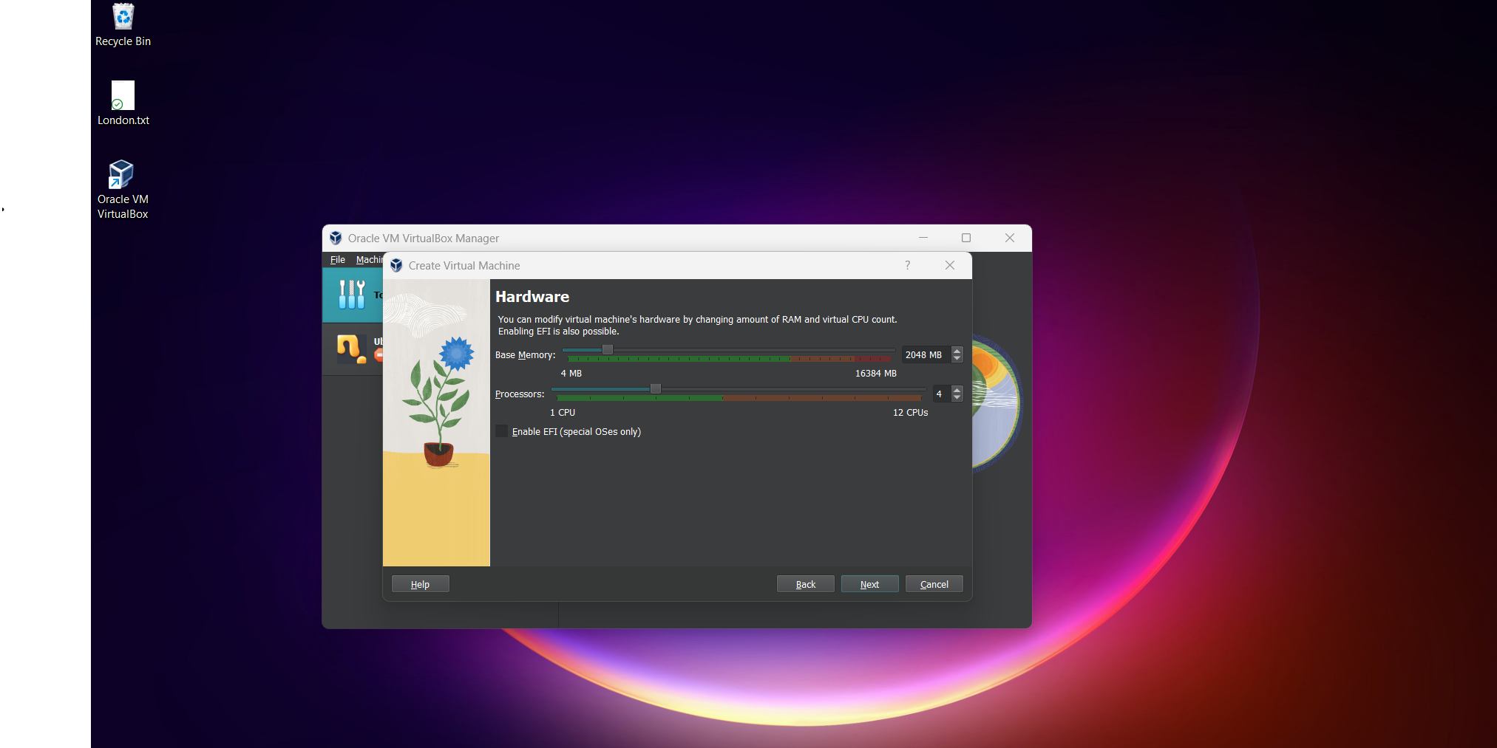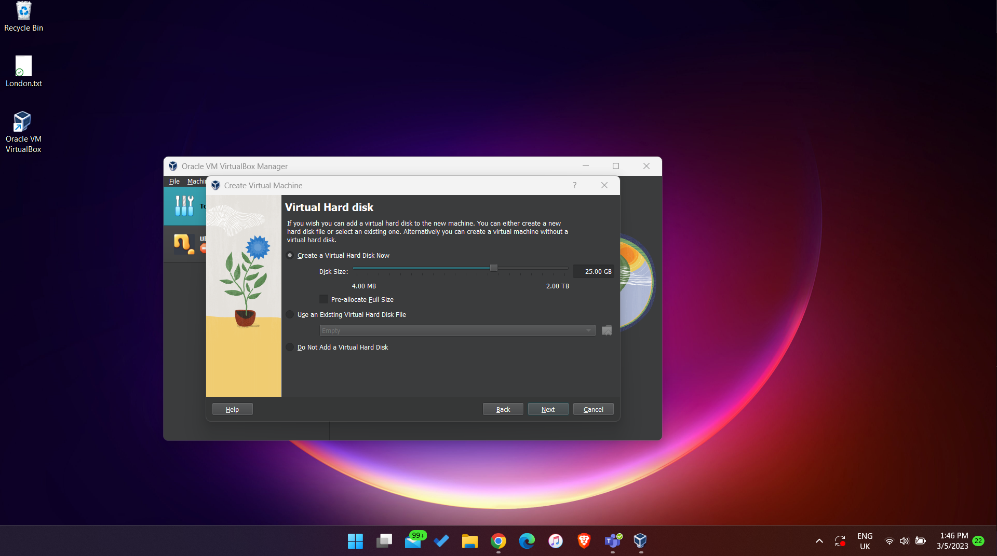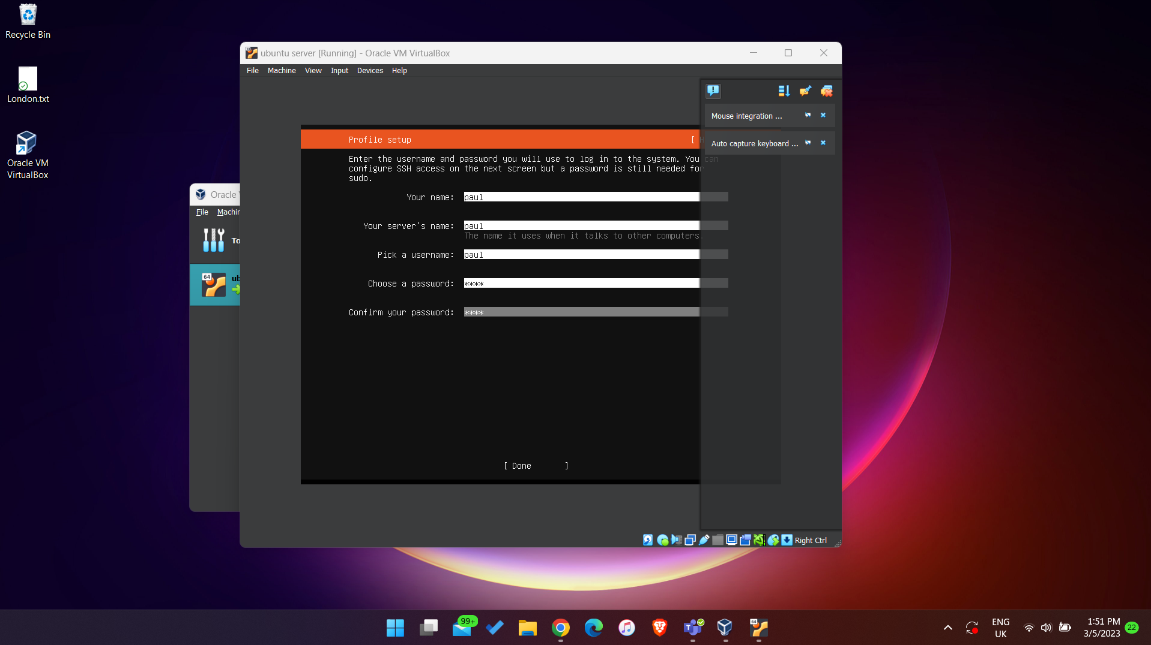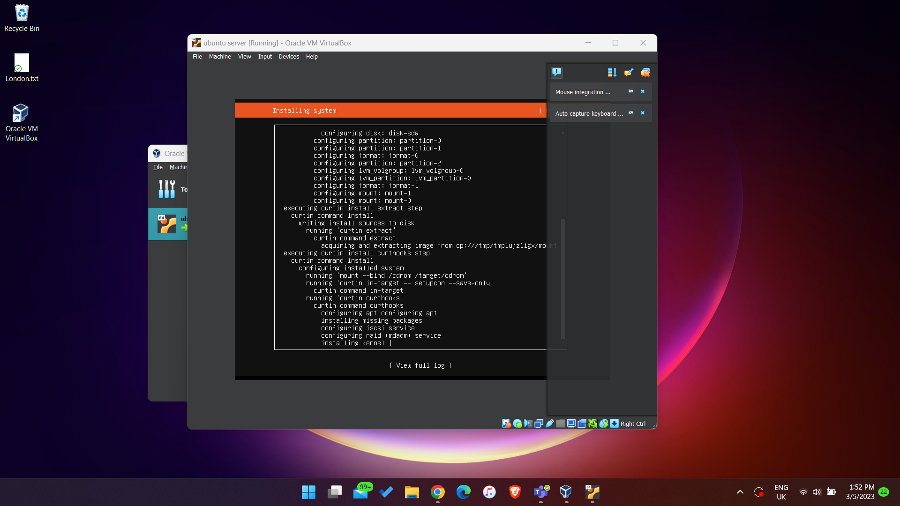

* We change the Virtual Network Adapter to Bridged Adapter, such that the VM will have an IP address in the same network class as our machine:

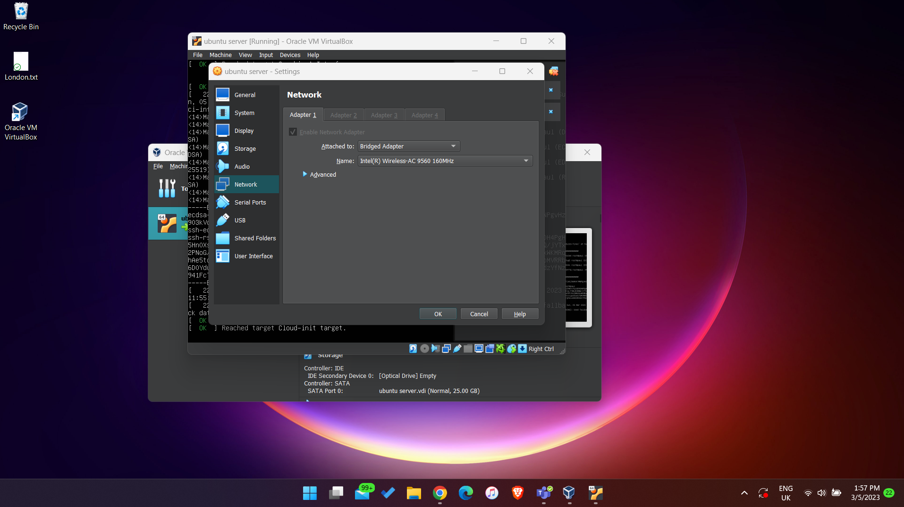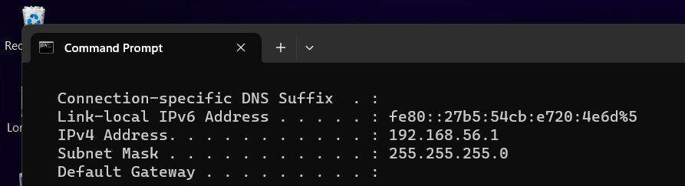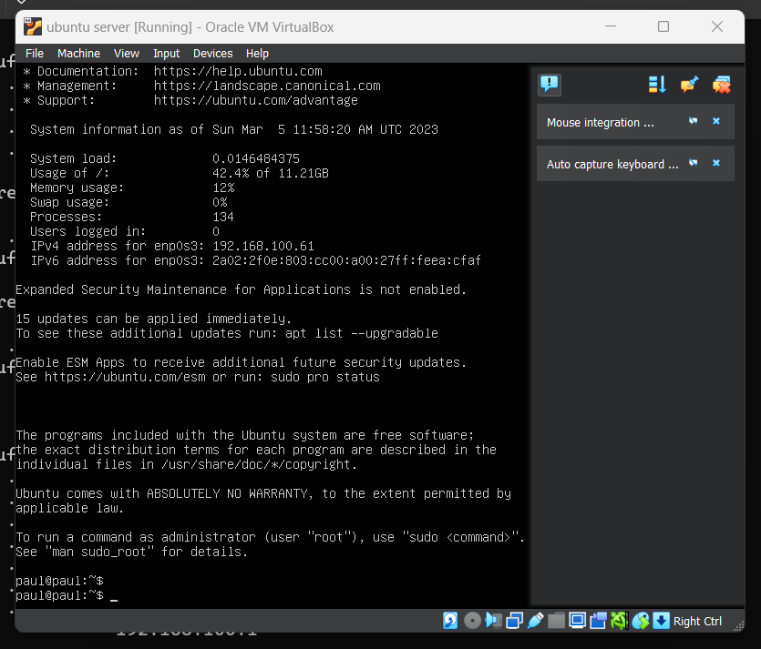

* We will connect to the Ubuntu Server from Putty later.

**Windows 7 Installation**

* I also installed Windows 7 Ultimate on the VM:

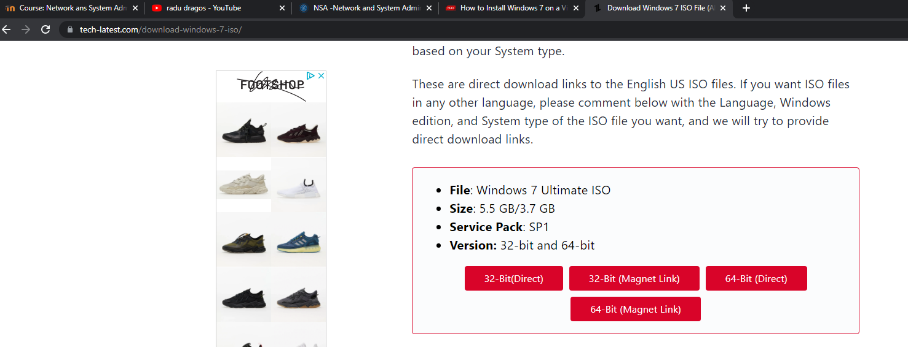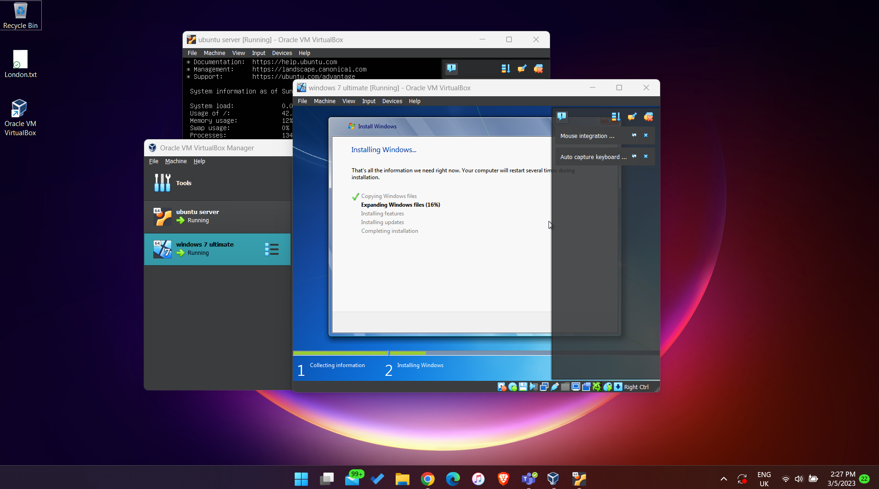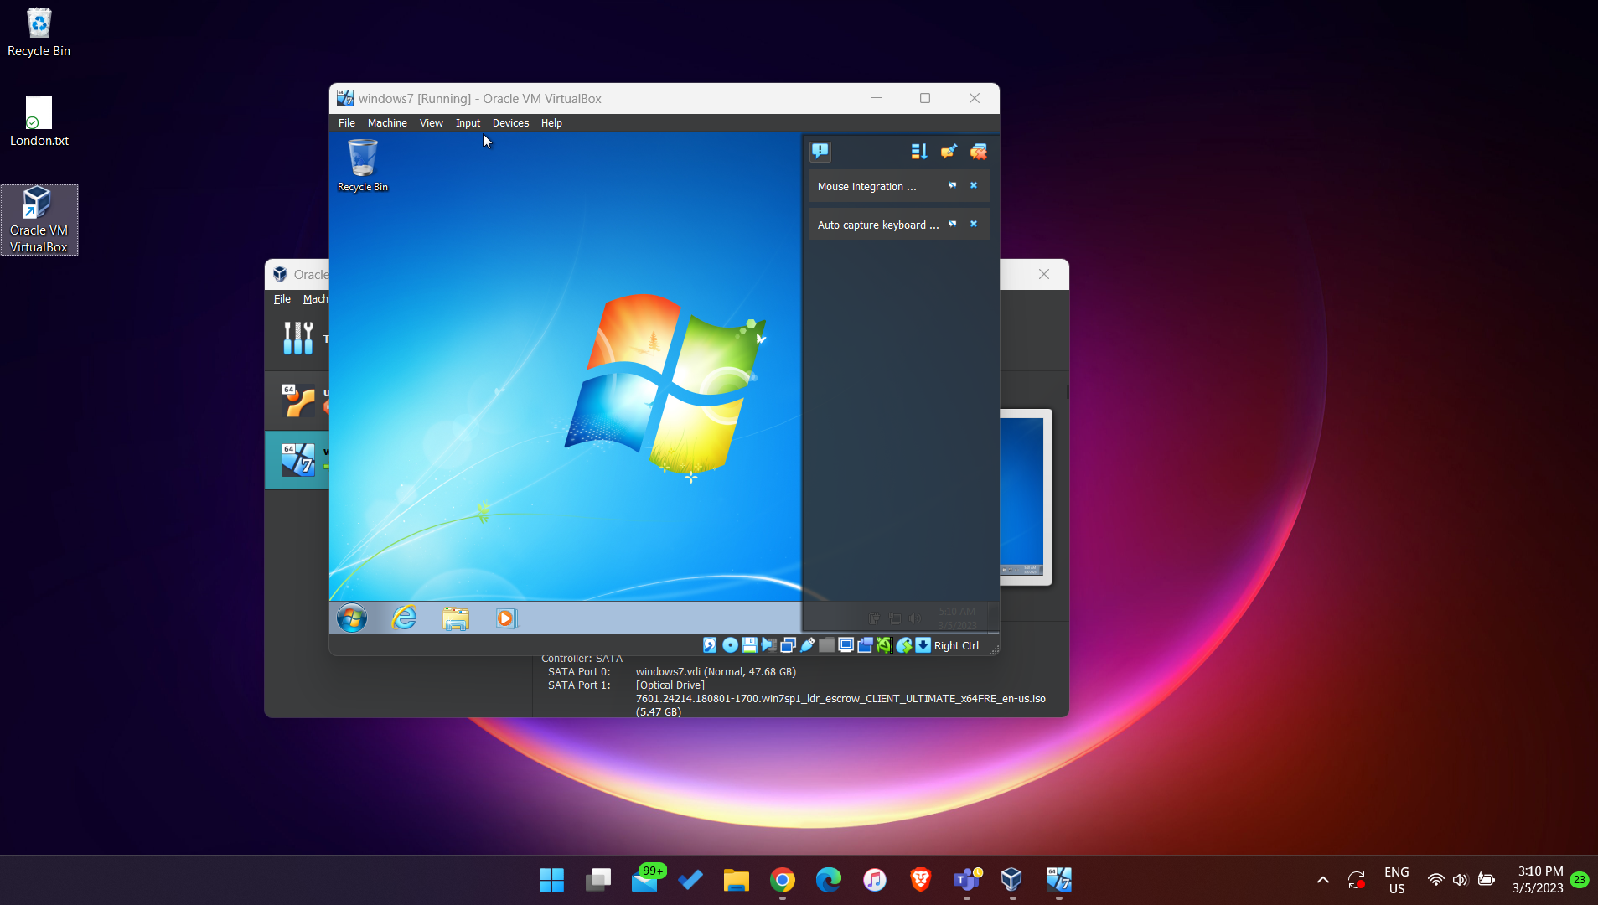

**Install and Connect to OpenSSH Server**

* First, we update the sources, then we install OpenSSH with the following commands:



* We can check with the command “ifconfig” the IP address of the server (we use it in order to connect to it with Putty):

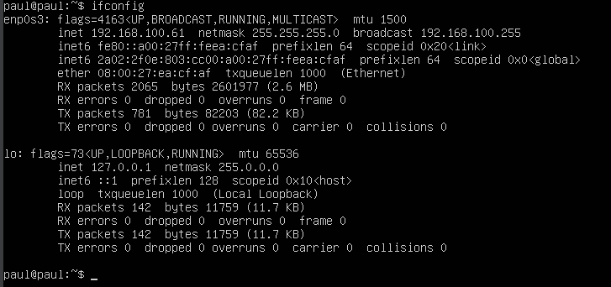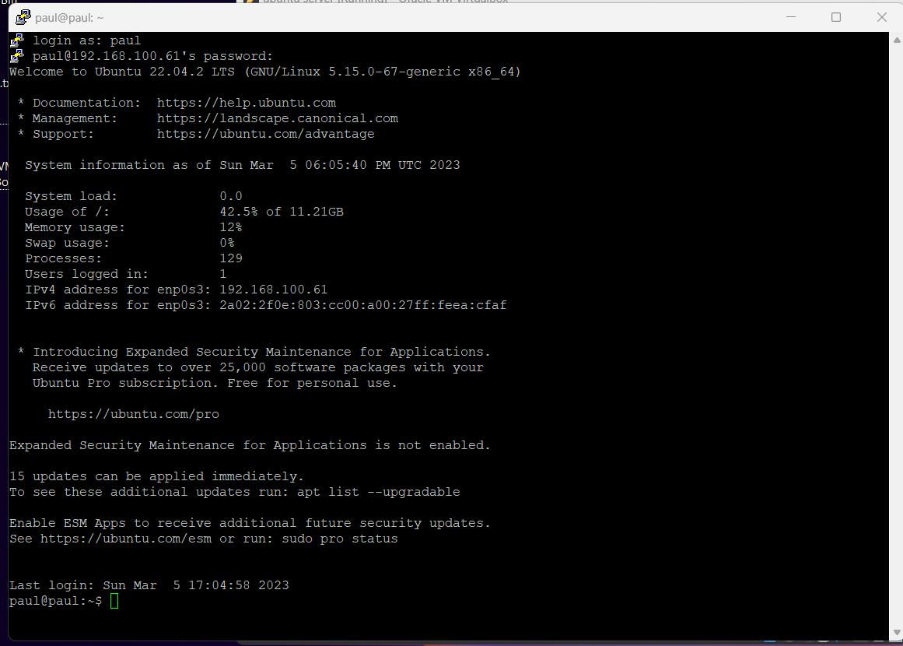

* We can check that SSH works with the following command:

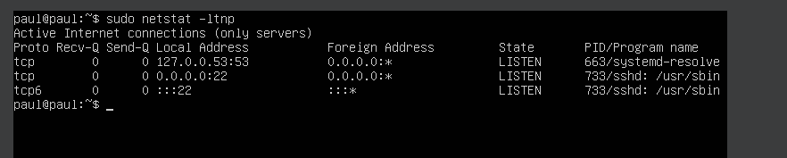

**SCP File Transfer**

* First step is to install WinSCP:

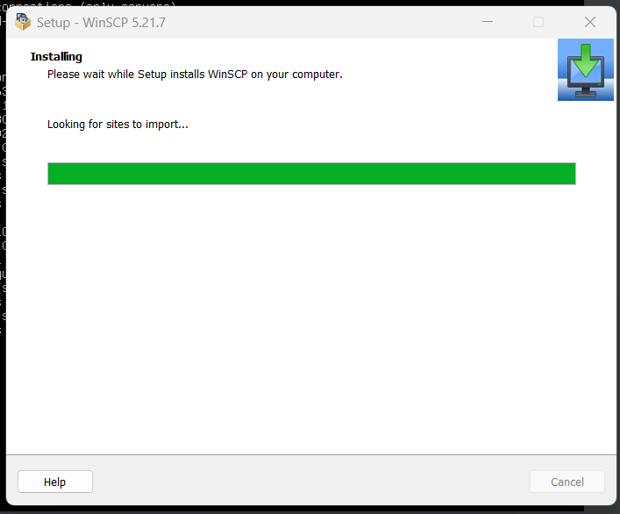

* Then, we will connect to Ubuntu’s IP address:

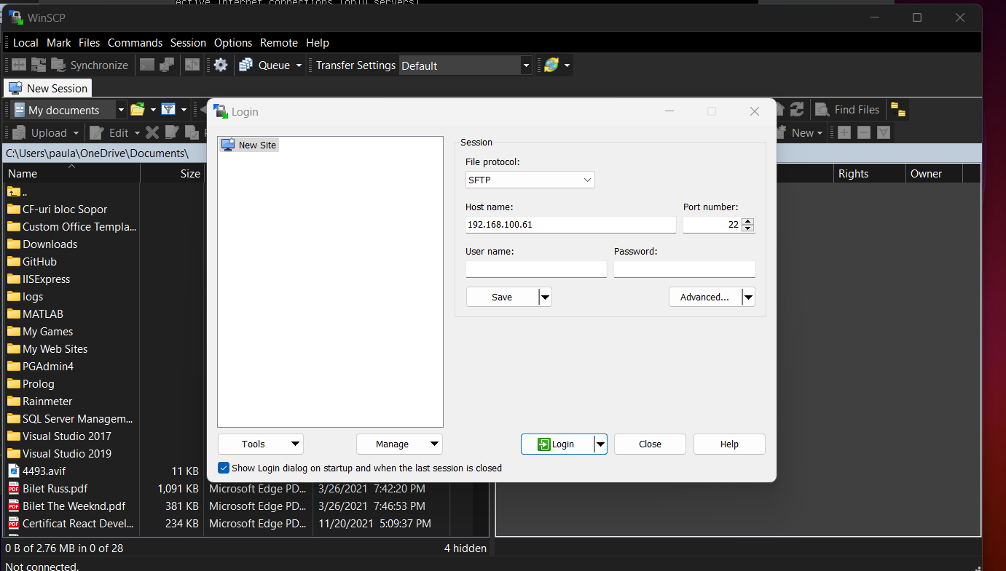

* Now we can transfer documents from our machine to the VM:

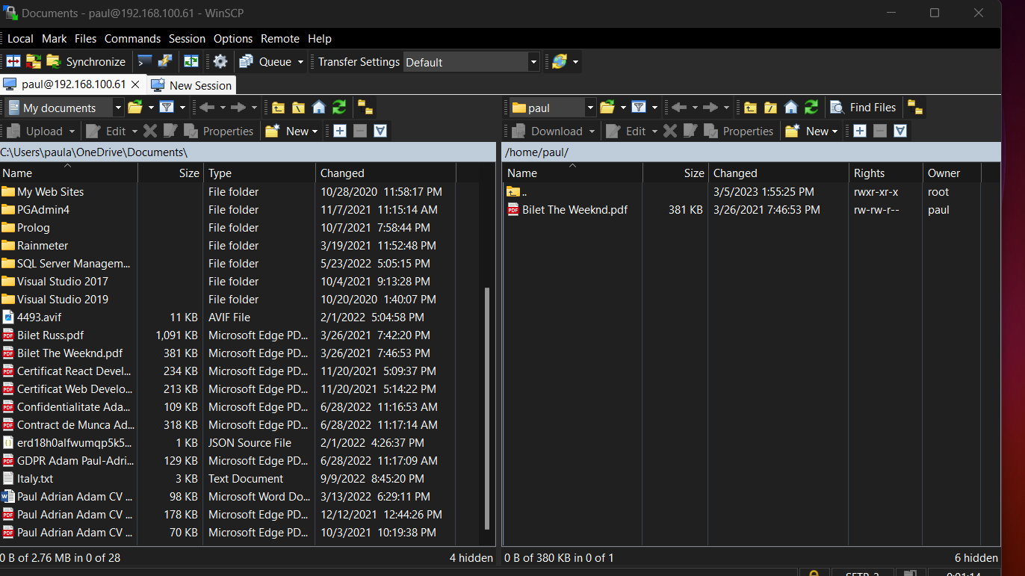

* Check that the document can be found on Ubuntu:



**LAMP**

* First, I will make myself a super user (such that I don’t need to write sudo anymore):



* Install LAMP with the following command:



* Navigate to Ubuntu’s IP Address from the local machine in order to check that the LAMP server is correctly installed:

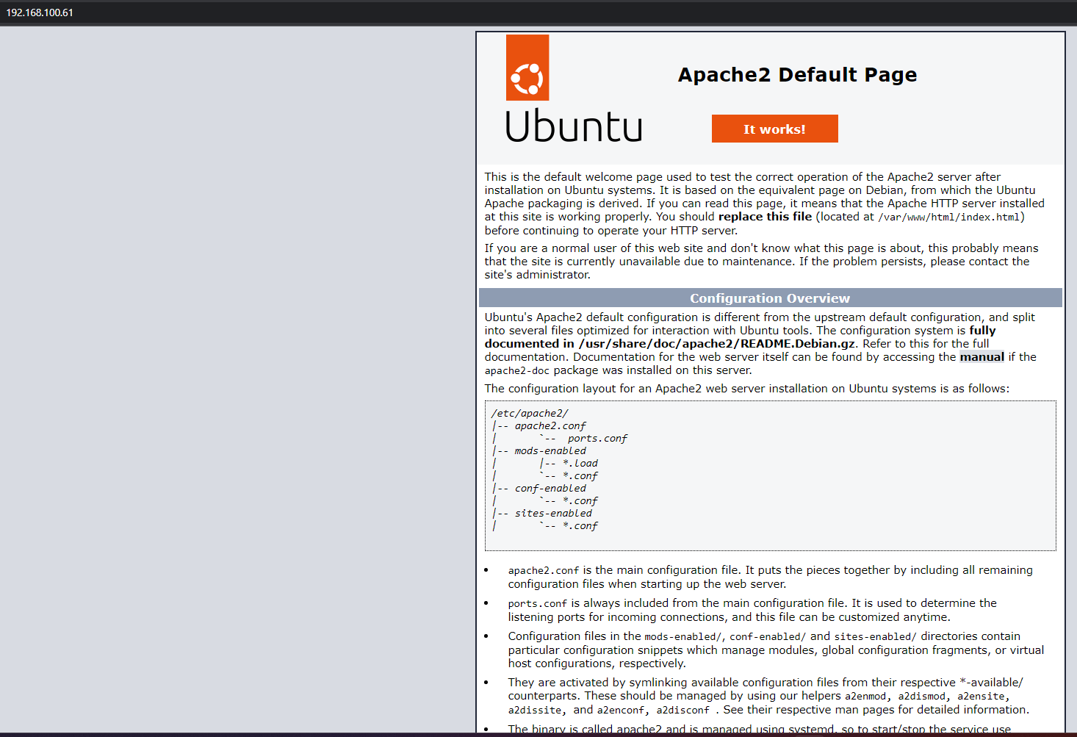

* Check PHP’s version:

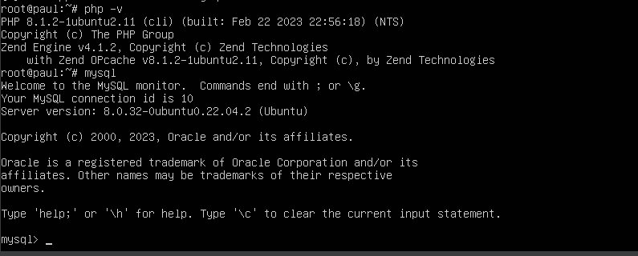

* Update the default page:

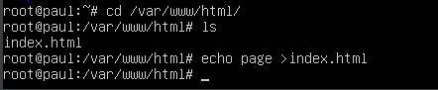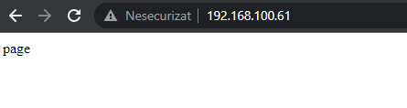

**Ubuntu as a Mail Server**

* Install Postfix as a mail server for Ubuntu:



* Verify that Port 25 is open and waiting for connections:

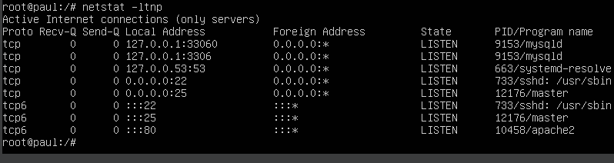

* Connect to TCP Port 25 by using telnet, then send a fake email:

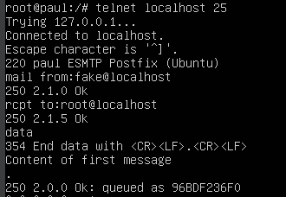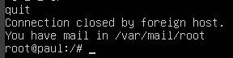

* Check that the email was received:

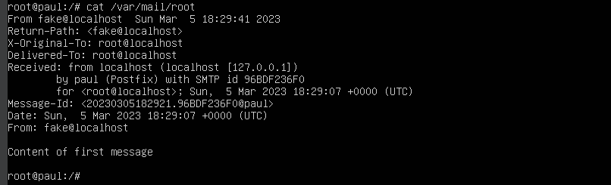

* Another solution can be to use the command “mail” in order to send emails:

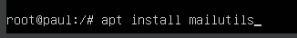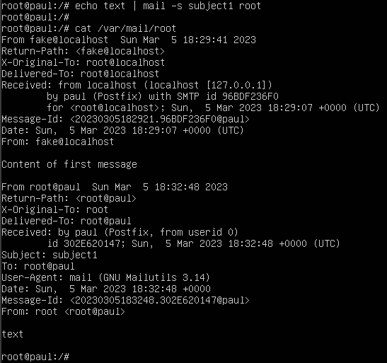

* By using just the command “mail” we can choose what email to read:

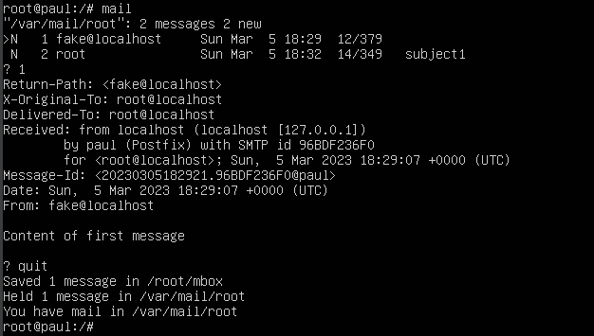

* A more advanced way would be to use “alpine” (it has a user friendly interface):

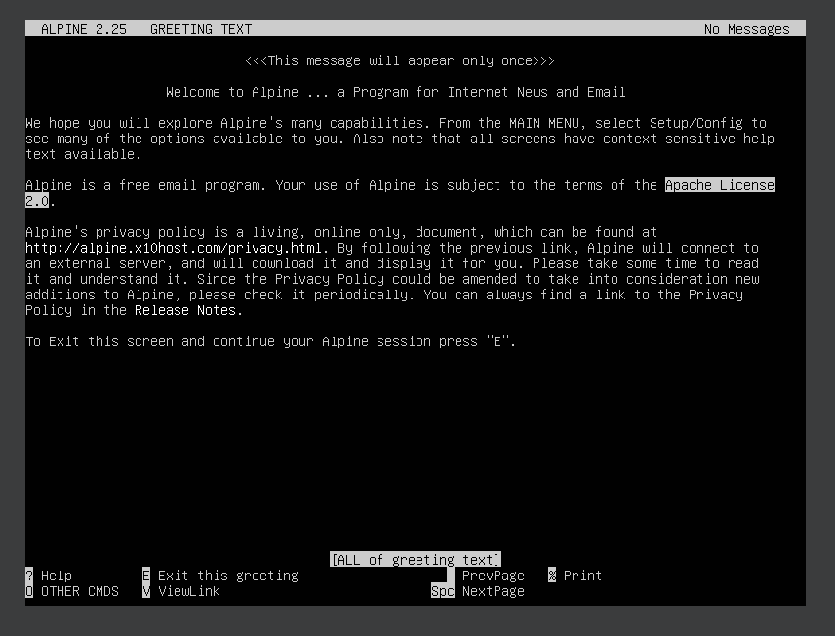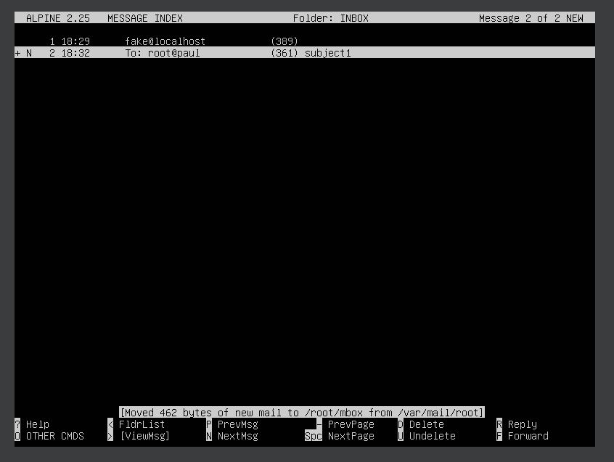

**Install FTP Server on Ubuntu**

* First, we need to install vsftpd (FTP Server):

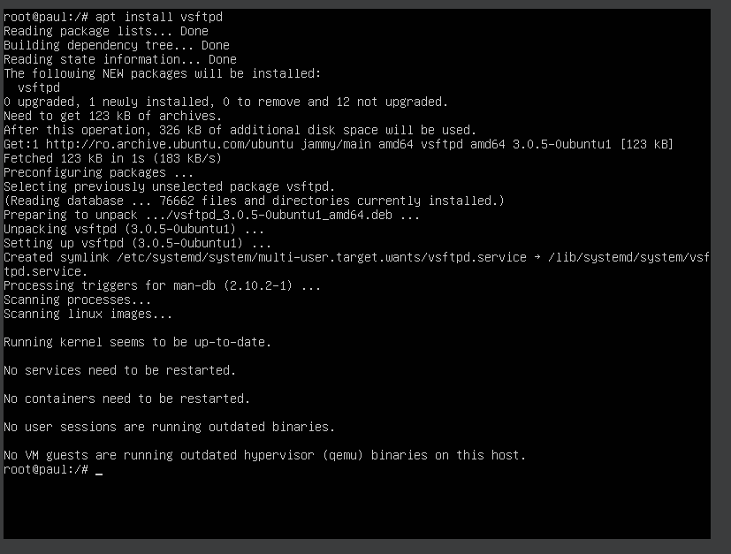

* We can check the status of an FTP Service with the following command:

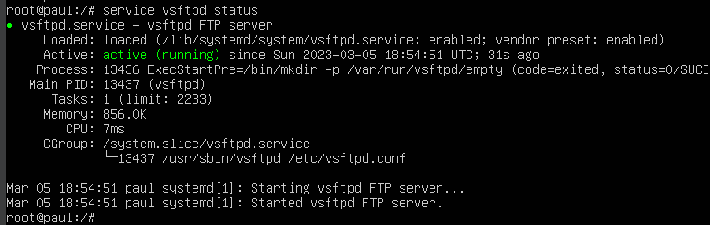

* Configure FTP Server:

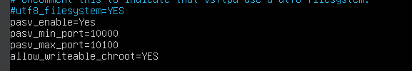

* The FTP Server listens to Port 20, with the following command we configure the traffic rules over the firewall:



* Now, we need to restart the FTP Service:



* Run the “ftp” command followed by the server IP to test the FTP connection:

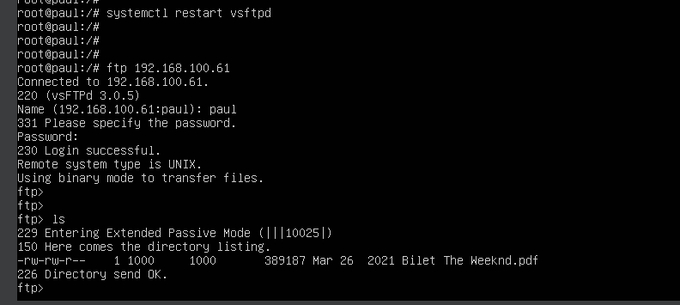

**Install DHCP Server on Ubuntu**

* Install the DHCP Server with the following command:



* Open the configuration file for the DHCP and add your network interface and other options such as the subnet address and the IP range:

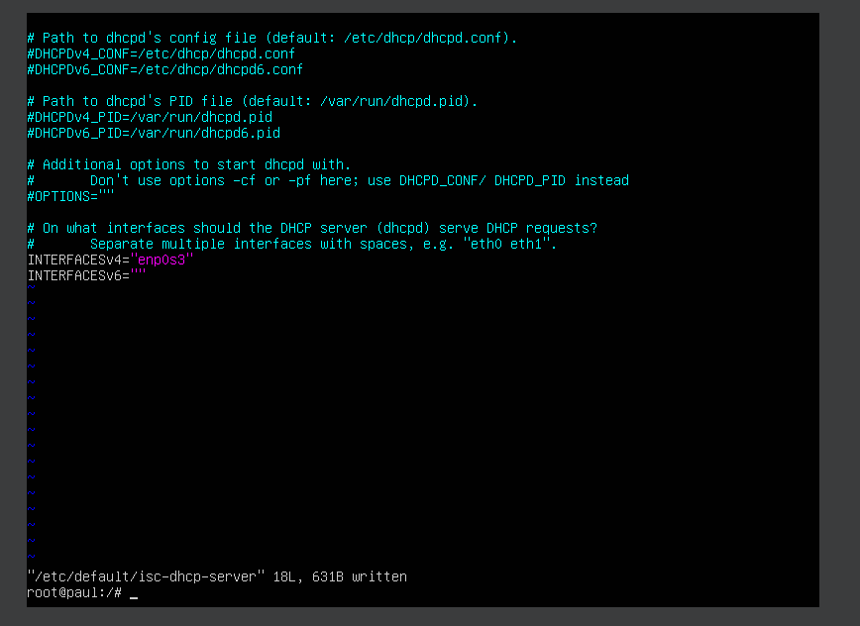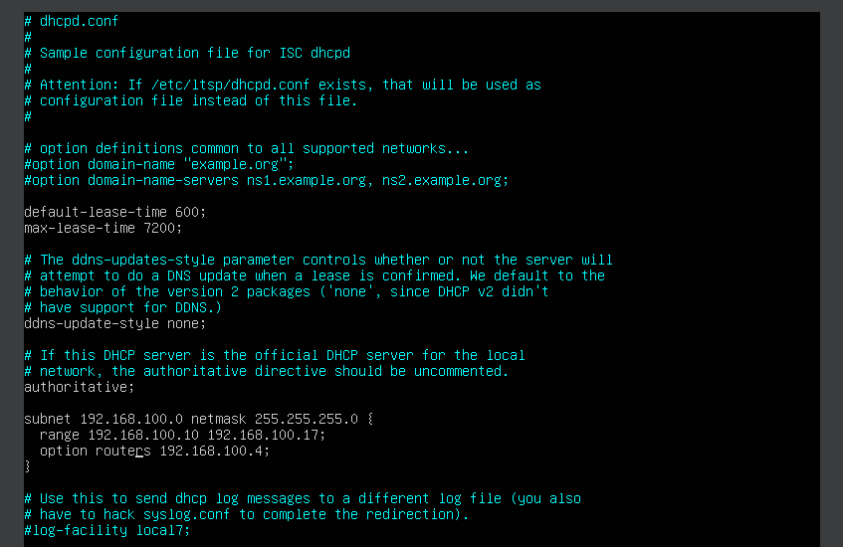

* This were calculated using “ipcalc”:

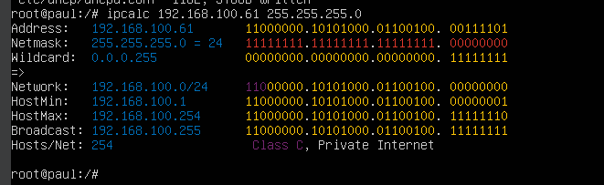

* Next, start and enable the DHCP server:

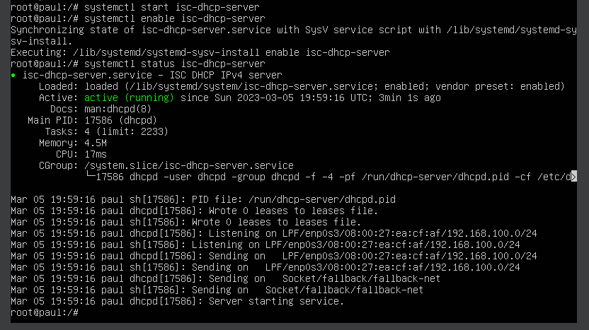

**Install Squid Proxy for Private Connections on Ubuntu**

* First, install Squid Proxy with the following command:

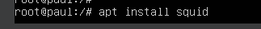

* Check that the server is running properly:

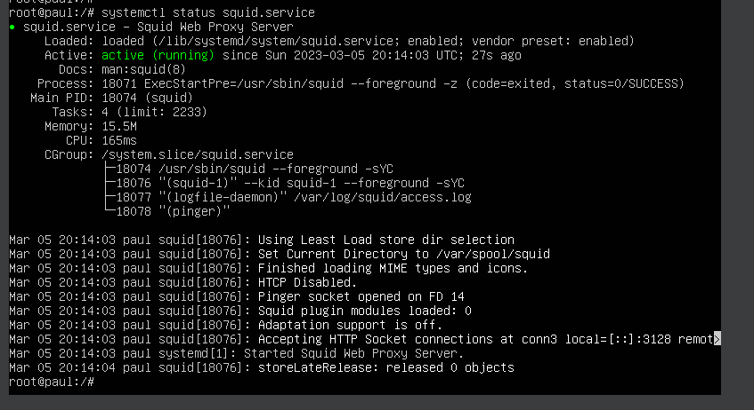

* Change the configuration file such that Squid will allow clients to connect to it:

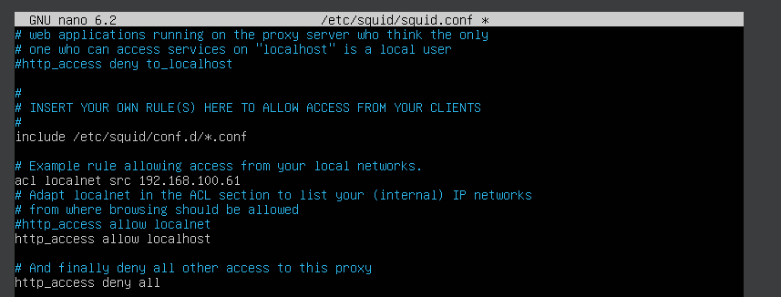

* Install Apache project in order to have access to a password generator that Squid likes, then use the “httpasswd” command in order to generate a password for a new Squid user:

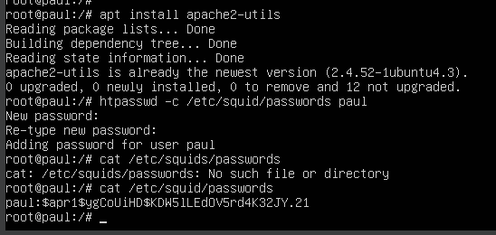

* Update Squid’s configuration to use the new /etc/squid/passwords file:

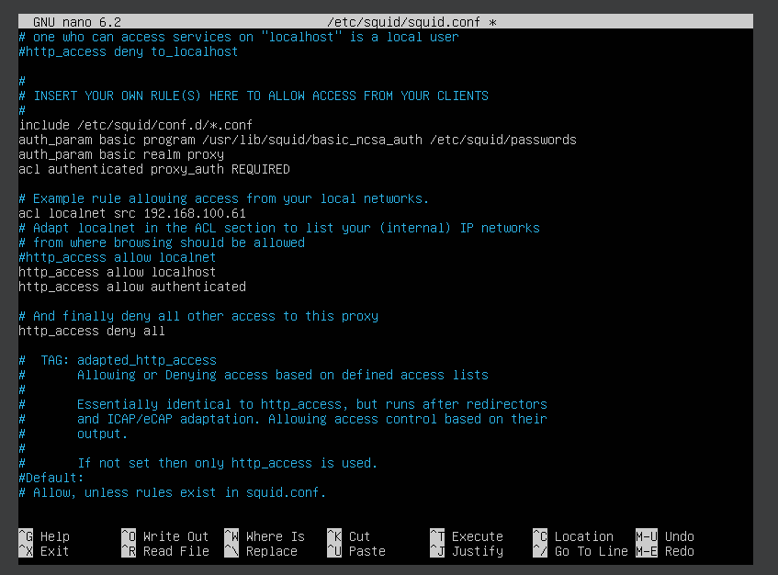

* Restart Squid and open Port 3128 in the firewall:

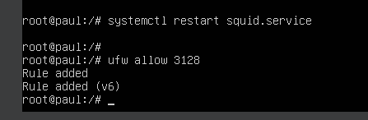

* Connect through Squid using “curl”:

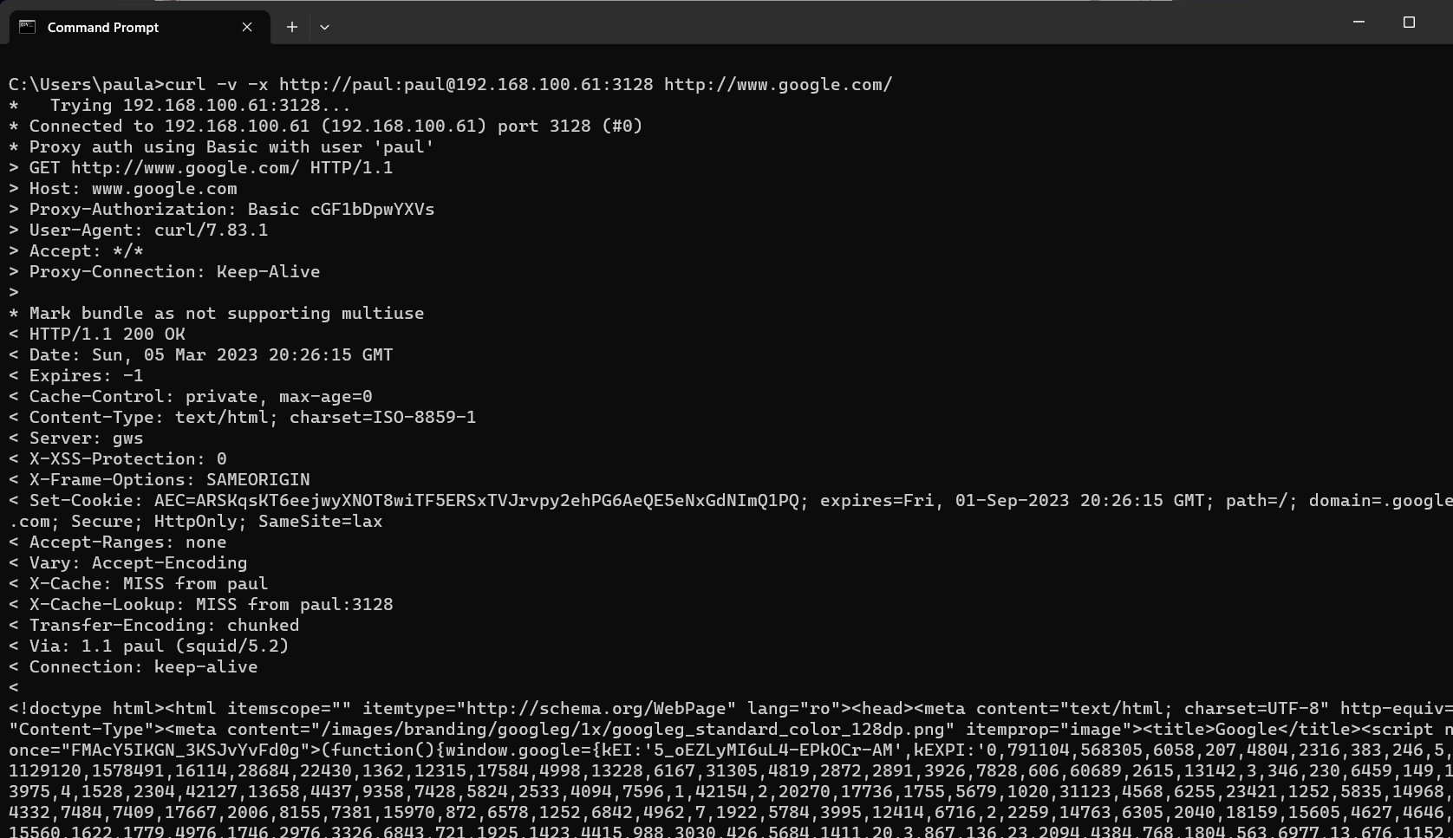

**Install DNS Server on Ubuntu**

* The package name of the DNS Server in the Ubuntu OS is “bind9”:



* Create DNS zones for the domain (Forward Zone and Reverse Zone):

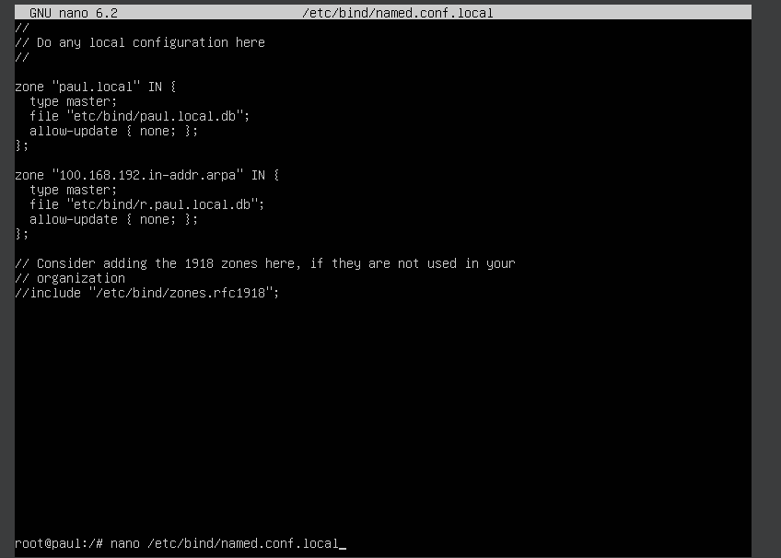

* Next, create Forward Zone File:

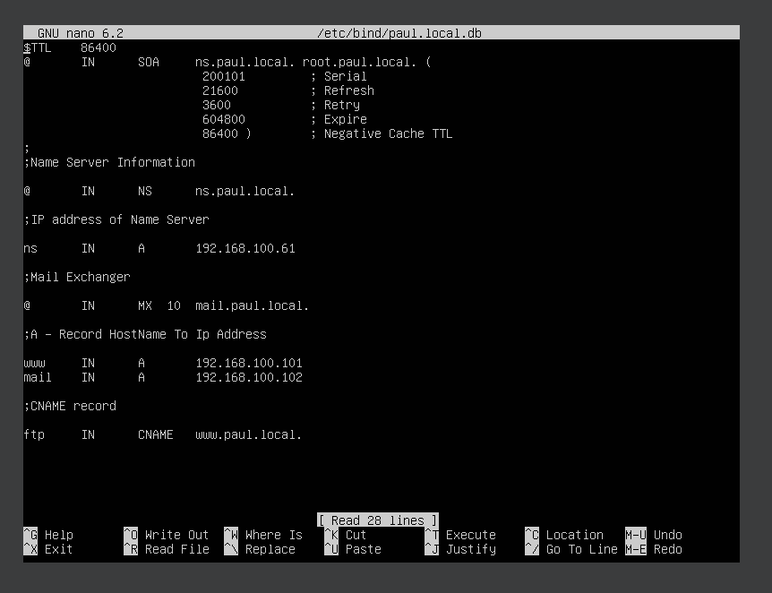

* Also create a Reverse Zone File:

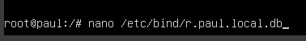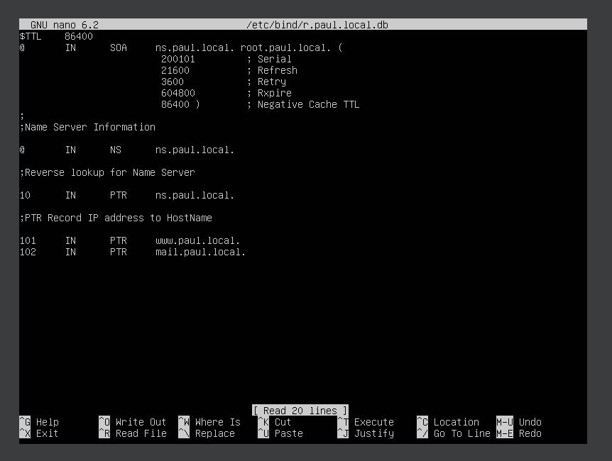

* Validate the DNS Syntax and reload the configuration file and zones:

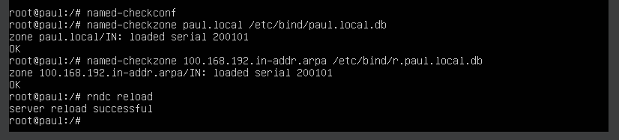

* Verify the DNS Server using “dig”:

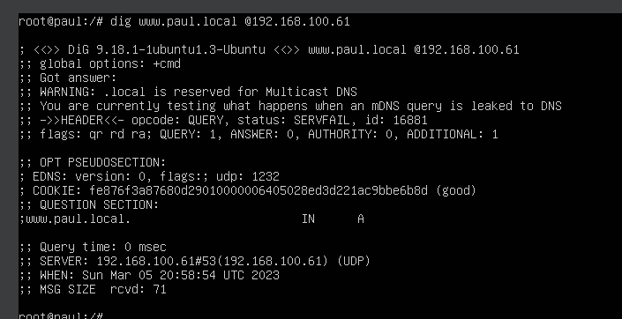

* Confirm the reverse lookup also:

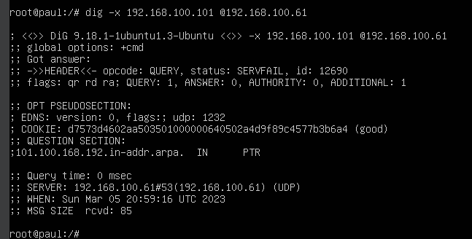

**Install Monit monitoring on Ubuntu**

* Install Monit with the following command:

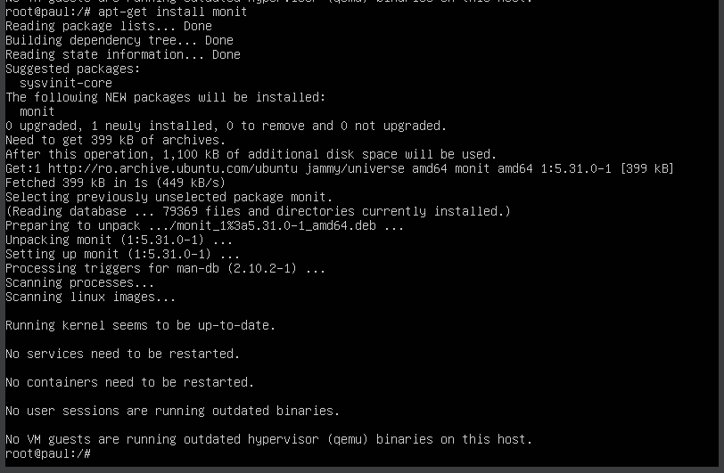

* Check the status:

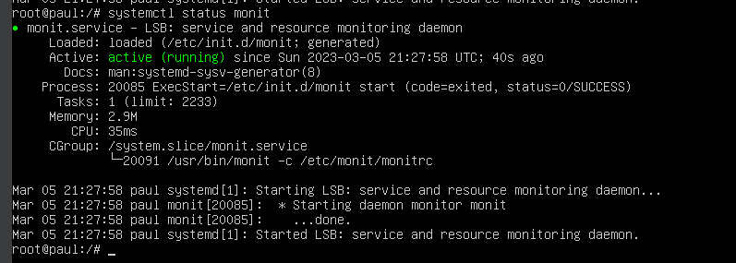

* Next, enable Monit httpd port (2812) on Ubuntu:

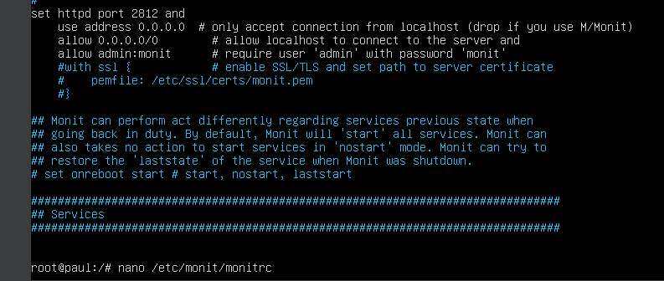

* Check for syntax errors:

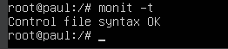

* Enable Monit Service, restart it and check its status:

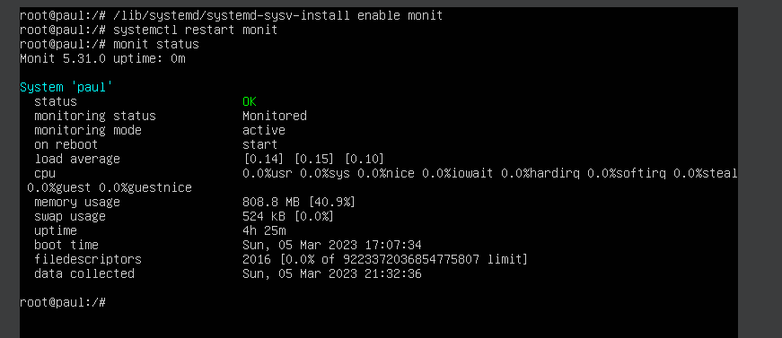

* Allow Monit Port in Ubuntu firewall:

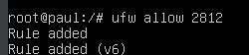

* Now we should be able to access the web interface:

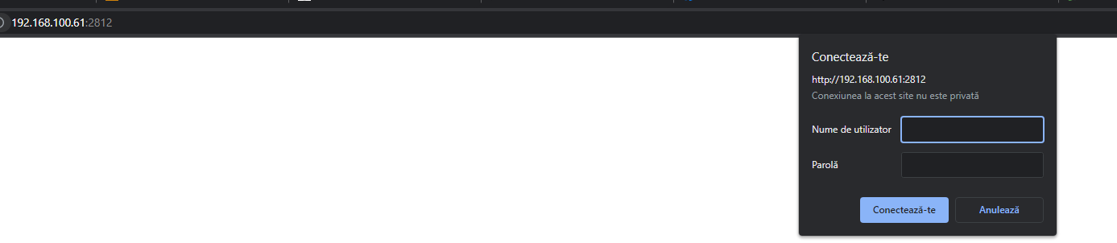

* We can add a new service manually in order to check Monit:

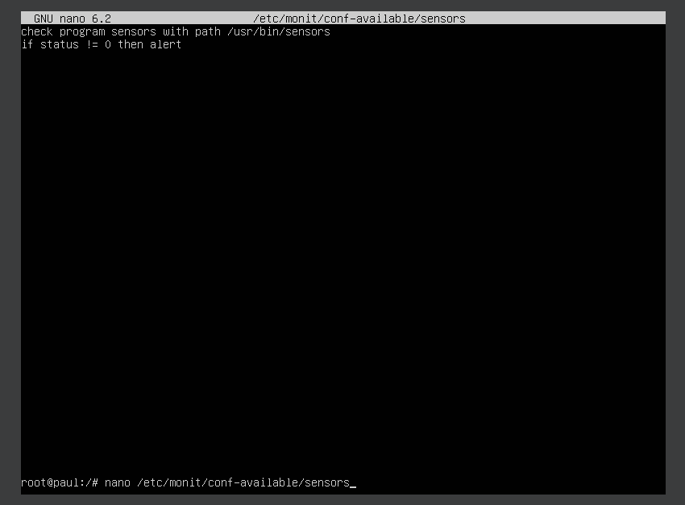

* Enable it:



* Reload Monit and check its status again:

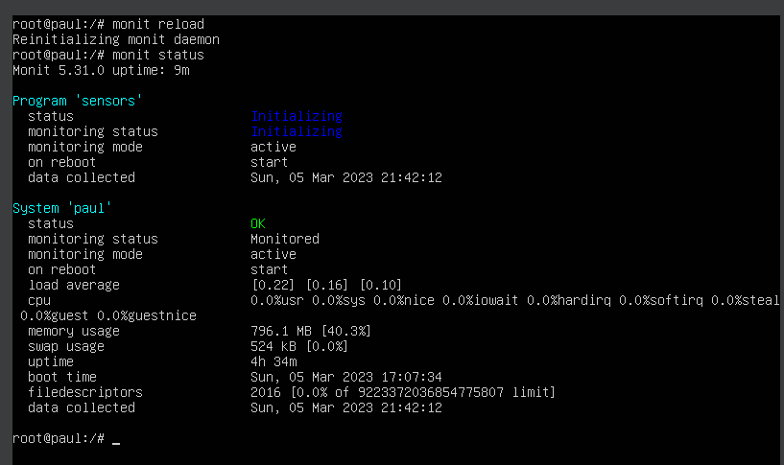

**Install GoAccess Web Log Analyzer on Ubuntu**

* First, install the required dependencies with the following command:



* Next, download the GoAccess source:



* Extract the downloaded file:



* Change the directory to extracted directory and configure GoAccess:



* Install GoAccess to the system using the following commands:



* In order to launch the GoAccess dashbord use:

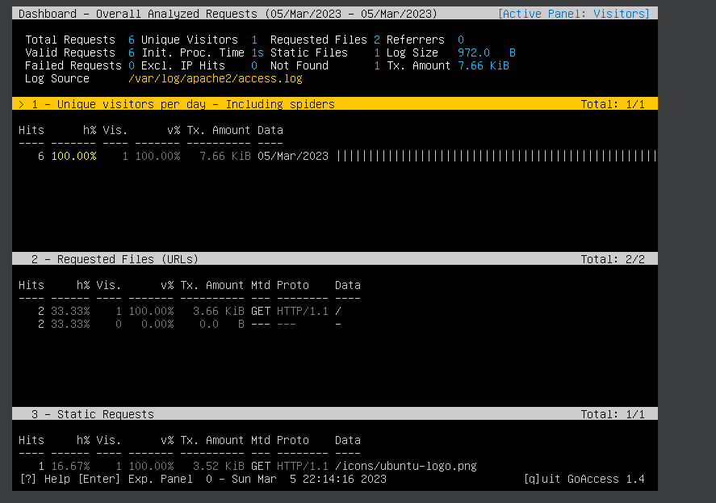

**Secure Ubuntu using Fail2ban**

* Install it with the following command:



* Open the configuration file and change the following settings:

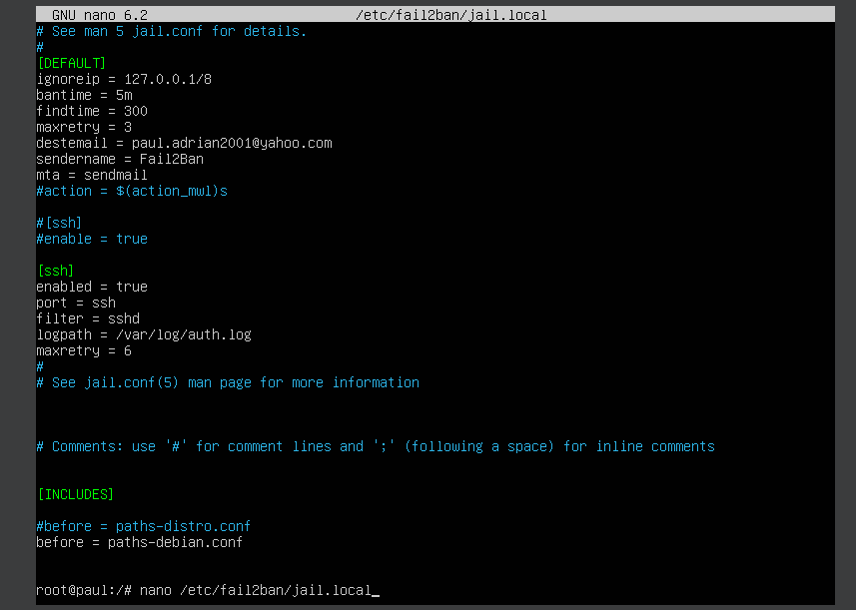

* Restart the service:



* Check the status (also disable firewall using “ufw disable”):

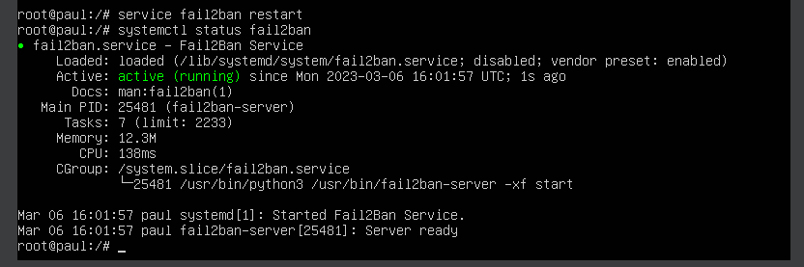

* If for some reason the service fails and it is inactive, we can check the full error logs using “journalctl _PID=XXX” (valid for all services).
* Try some failed SSH login attempts from your machine to check if Fail2ban works:

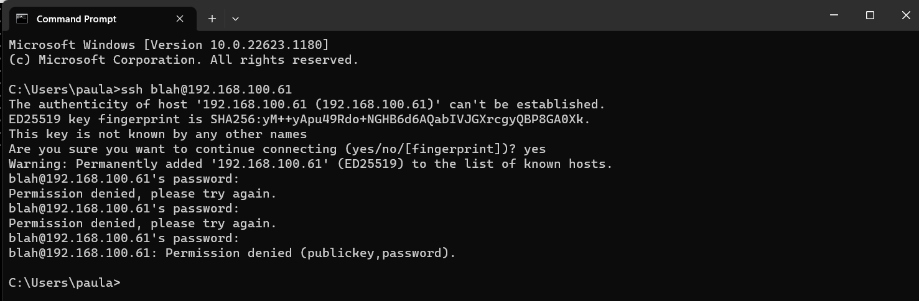

**Install Docker on Ubuntu**

* Run the following command to install the dependencies:



* Add the GPGK key:

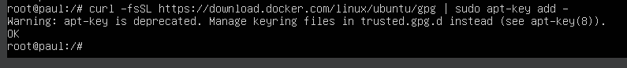

* Add the Docker repository:

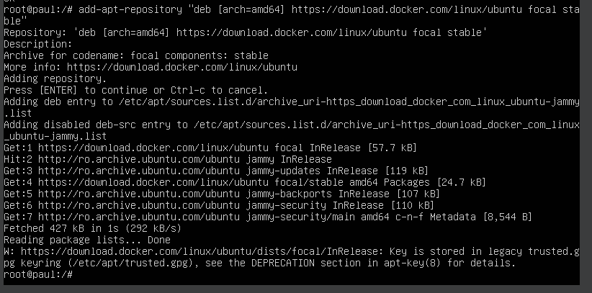

* Install Docker and the associated packages:



* Add the current user to the docker group and confirm that Docker is installed:

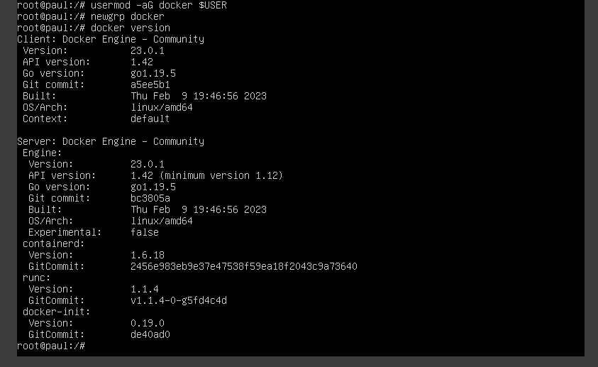

* Verify that Docker is started:

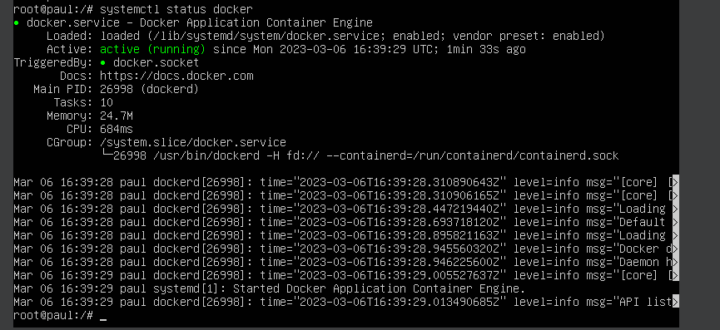

* Test Docker by pulling a “hello-world” image from Docker Hub:

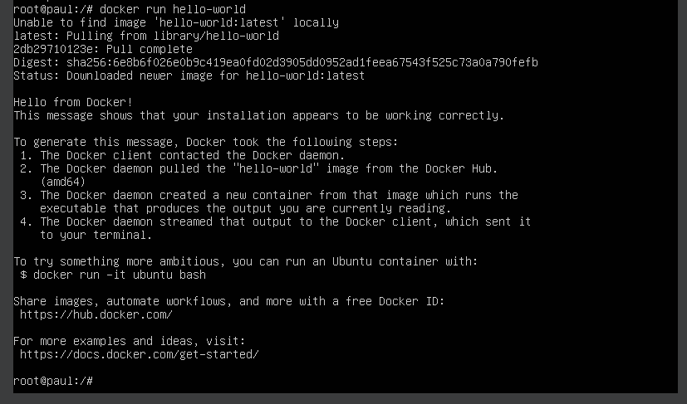

* Confirm the images on the system:

